**Automation in Water Reservoir Floodgates and Control Decision System**

***Abstract*—**System is applicable for Water Reservoirs or Dams with Hydro-Electric Power Plant and facilitates multi-step off-stream spillways opening. Design of Criterion Decision Analysis for generating accurate value to execute operational methodology of floodgates is prime objective of our system. Overview of Our system is described here: Ultrasonic are machinated to measure the water holding capacity level of particular Reservoir or Dam. Waterflow sensors, determine the water equilibrium level and transmits real-time value to Control Decision System. As per ISO-Code rule set for Water. During overflow or flooding, system will activate checkpoint signals and forward fast on the guard Alert message to nearby District Headquarters and National Risk Disaster Management Force to smoothly migrate humans from the flooded river region. System will share detailed information about Inflow and Outflow of water through Canals to Irrigation Department for Knowledgeable purpose. System will be administered by Water Resource Management Director of respective Reservoir or Dam. Finding alternative technology to overcome the issue of Sedimentation that reduces water storing capacity of particular Water Reservoir is future scope of our system.

1. **INTRODUCTION**

Automation in Water Reservoir Floodgates and Control Decision System refers to the interdisciplinary operation of Criterion Decision Analysis and Multi-Step Optimal Progression Approach for opening Floodgates that is operated through Control Decision System and monitored by the Executive Head of Water Reservoir or Dams. Its aim is to impart real time value of water holding capacity level excluding the sediment congregated at upstream of Reservoir.

System will incorporate the operational methodology as per the “Rule Operation Model for dams with gate-controlled spillways” while radial system that is machinated to lift-off the floodgates.

During the overflow or flooding, system will convey the “fast on the guard” alert message to nearby District Headquarters and National Risk Disaster Management Force Executive team to migrate humans from flooded region or river banks at the execution of floodgate openings through service functionality of application designated.

*Classification of dam based on size*

|  |  |  |
| --- | --- | --- |
| **Classification** | **Gross Storage** | **Hydraulic Head** |
| **Small** | Bet. 0.5 and 10million m3 | Bet. 7.5m and 12m |
| **Intermediate** | Bet. 10 and 60million m3 | Bet. 12m and 30m |
| **Large** | Greater than 60million m3 | Greater than 30m |

1. *Sedimentation*

Reservoir sedimentation is caused due to the flow of water and sediment into the reservoir. Basically, all sediment (gravel, sand and mud) transported to a reservoir by a river is derived from erosion of land surface. When river flow enters a reservoir, its velocity and hence transport capacity are reduced

and the sediment load is deposited in the reservoir.

(see Figure 1). The amount of sediment deposited depends on the types of sediment in the river system, the shape of the reservoir, the detention storage time and the operating procedures.

The principal sedimentation processes in reservoirs fall into mainly three categories:

• deltaic deposition of the primarily coarse (gravel and sand) materials (in entrance section of reservoir)

• deposition of the fine sediments (silt and mud) from homogeneous flow

• deposition of the fine sediments (silt and mud) from stratified flow (turbidity current)

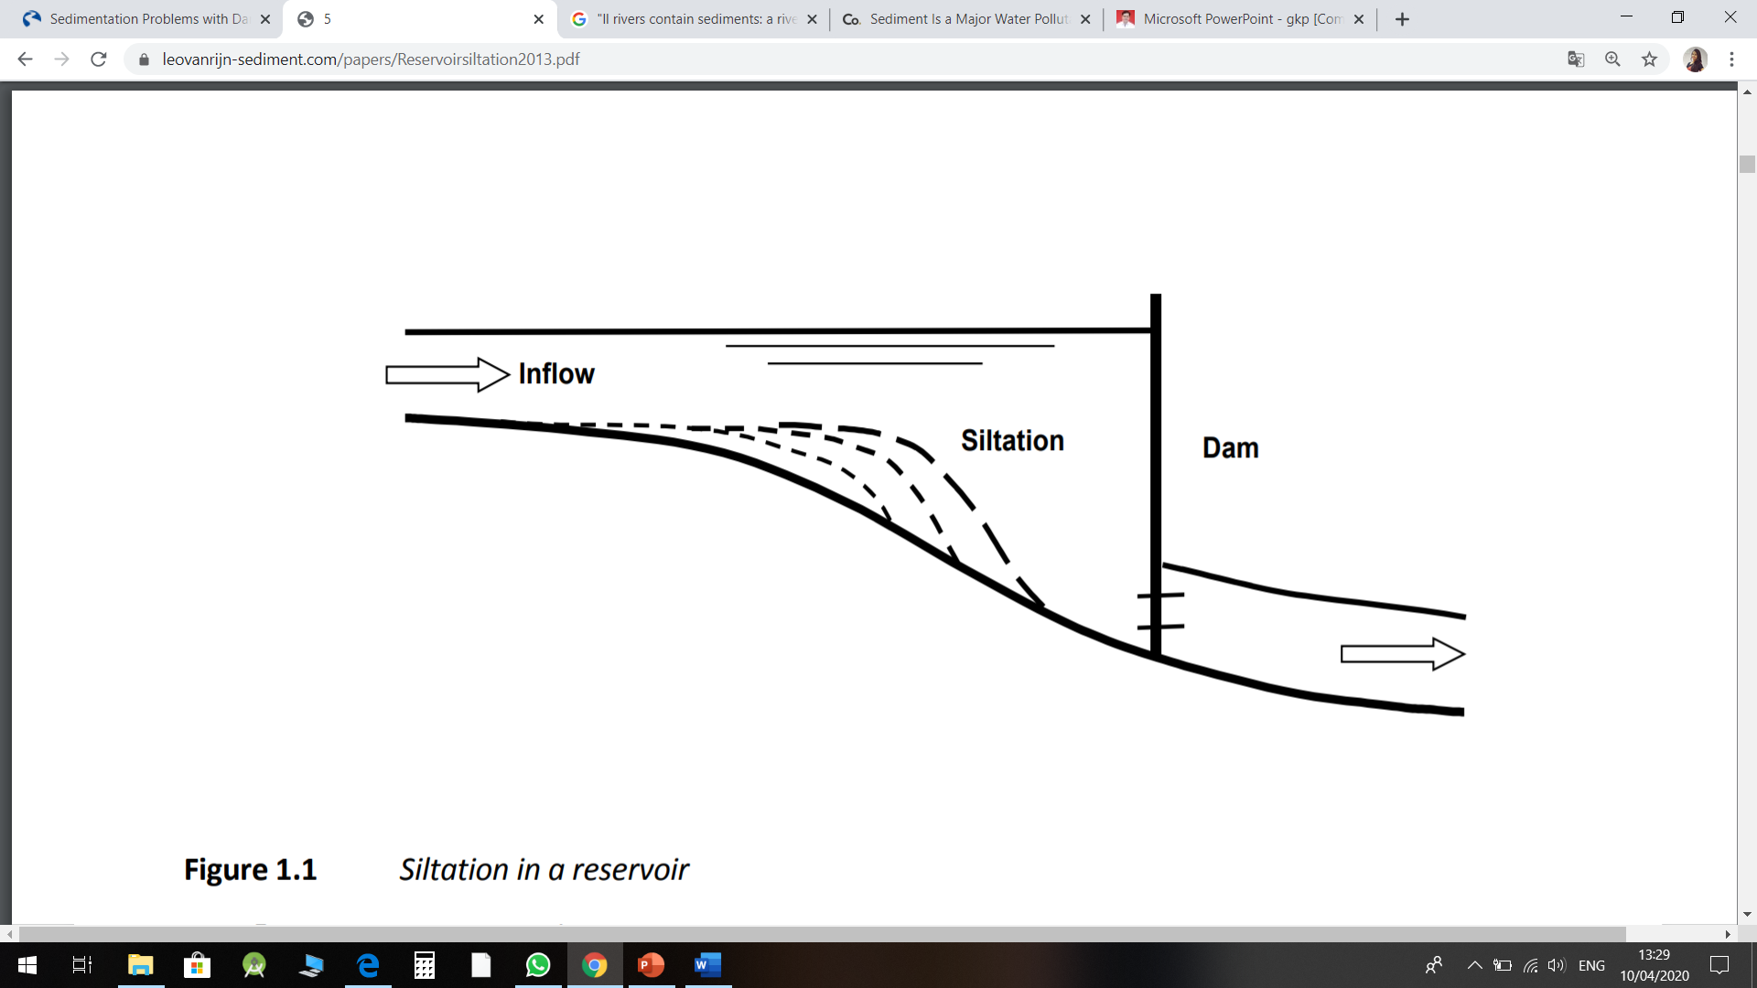

Fig 1: Siltation in a resevoir

Measures to reduce the sediment input into a reservoir are:

• replanting and reforestations of eroded areas (soil conservation)

• crop rotation and regulation of grazing

• terracing of relatively steep valley slopes

• bypassing of sediments (bypass channels)

**II. SYSTEM PROCESS**

1. *Architecture diagram*

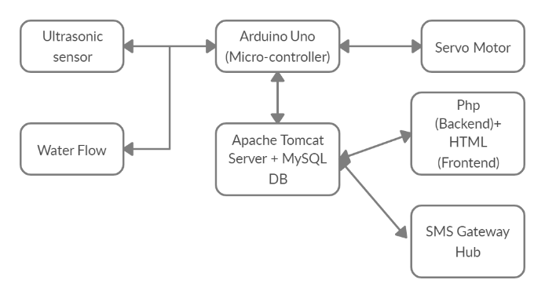

*Fig2: Overview of architectural dia.*

1. *Prototypes*
2. Ultrasonic sensor evaluates depth of sedimented cluster present at upstream.
3. Water flow sensor determines the water holding capacity of reservoir.
4. Servo Meter triggers radial system which lift-offs floodgates when limit gets exceed.
5. SMS Gateway Hub acts as bridge to transmit alert message to administrator.
6. *Technologies:*
7. Hardware Interface

Ultrasonic

Water flow

Arduino uno

Servo motor

1. Software Interface

Arduino uno

Apache tomcat server

Php (back end)+ HTML (Front End)

Sms gateway hub

